**Representing a face as a set of Measurements-**

Compare faces Directly –

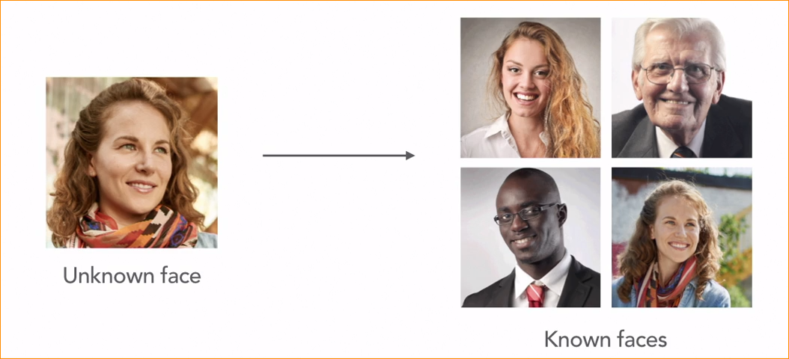

We have unknown face

And we have set of faces that we already know call the known faces.

We have to find what is the best face that match to unknown face.

The picture that has common pixels that must be best match.

However, this simplistic approach has two big problems.

1. Comparing images doesn’t work(if we have lot of known faces )

* Too slow – directly comparing every pair of images would be too slow.
* Doesn’t capture he structure of each face (just compairing images them self isn’t really the same as comparing the structure each person’s face. )
* Human can recognize two people that nearly similar to each other. So we need that kind of model.
* The solution is come up with a way to measure each face.

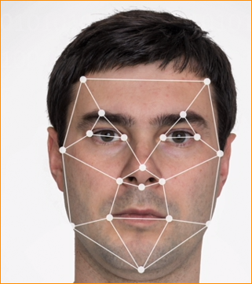measure each eye, size of the cheekbones and the width of mouth and so on.

If we have unknown face, check the measurements.

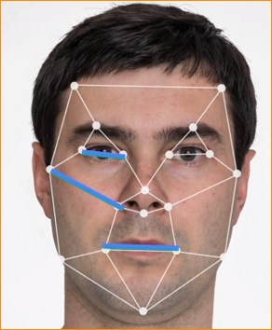

Here are two face , lets take three measurements for each face

1. Length of nose – 2.5 (left) | 2 (right)
2. Width of mouth – 2.5 and 3
3. Distance of one eye to other 4 and 3.5

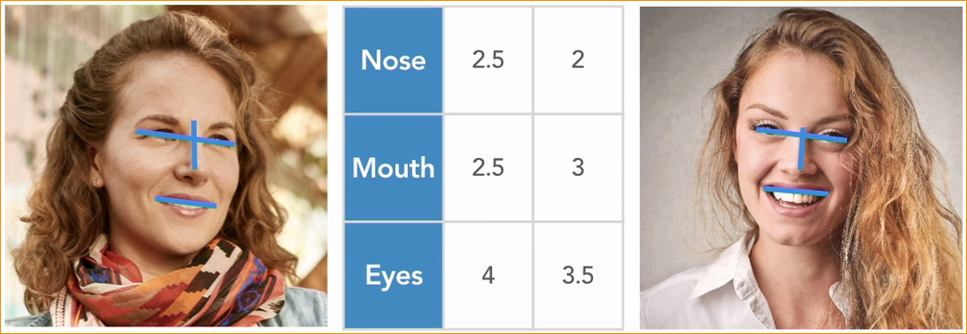

Now those measurement coordinates, draw in a space –

3 measurement that 1 st – 2.5 ,2.5 and 4 show blue

3 measurement that 2nd – 2 ,3 and 3.5 show yellow.

Now we can mesure the distance between two point of the 3D space.

That distance is relay small or close each other(two point) that may be a same person.

If large mean not a person

**Face Encoding** –

The process of taking an image of a face and turning it into a set of measurements.

A real face-encoding system will capture a large number of faces measurements(typically 128 or more)

ML algorithm creates measurements for us.

**Automatically generating Face Encoding –**

Which measurement best for represent the face –

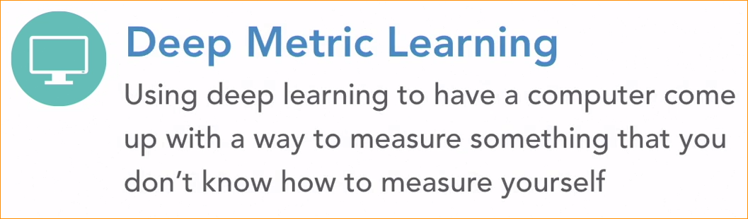

Using deep convolutional neural network to come up with its own set of facial measurements instad call deep matric learning.

How its work?

Training with Triplets –

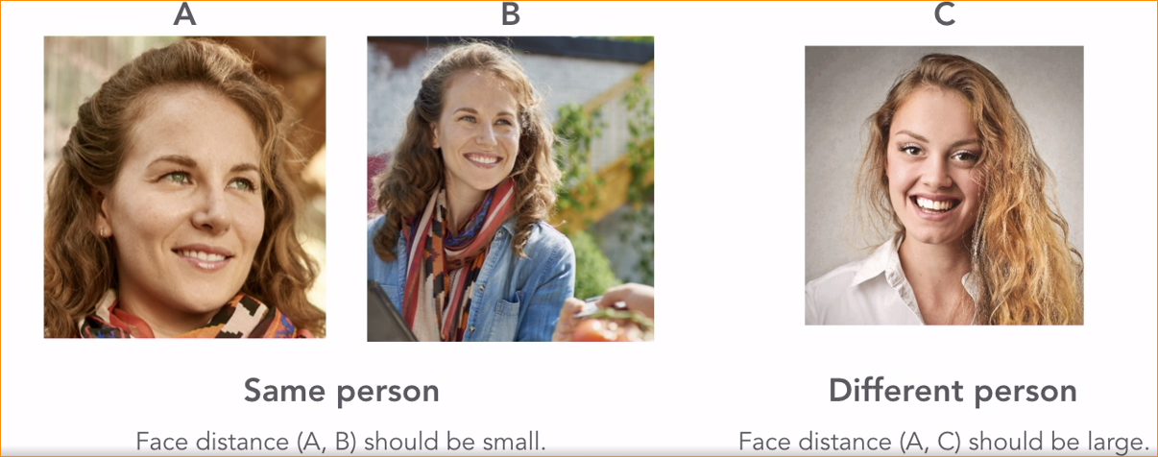

* Here are three pictures labeled A,B and C
* Picture A and B are the same person.
* Picture C is the different person.
* Face distance (A and B) Should be small. Because it is small person.
* C has large face distance
* We can use this idea to set up ML algorithm.
* We fed millions of photos into a neural network. In group 3 like this.
* These groups of three are call triplets.
* Each triplet will have two pictures of the same person and one picture of a different person.

ML algorithm job is to figure out how to represent each picture as a set of 128 measurements. The 3rd person measurement close together. Each time algorithm seen the triplets, if tweaks the face measurements it is generating little bit close to that goal. By repeating millions times with millons of pictures , the machine learning algorithm eventully learns how to generate a set of face measurements.

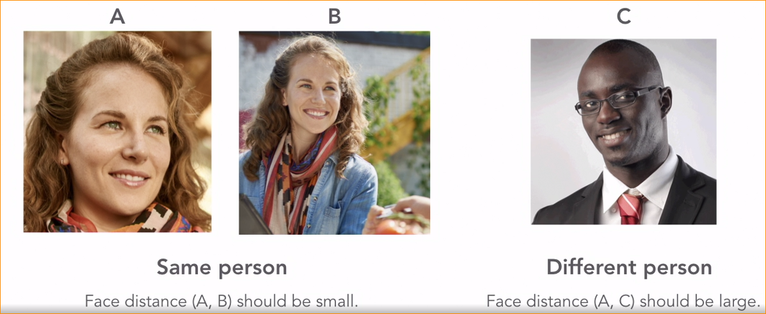

In here first 2 pictures has same measurement and two pictures and 3rd one has different measurement.

After training the model call the face encoding model, bez encoding the measurements. After the face encoding model is trained, if we feed any face the model should create 128 numbers that represent that face.

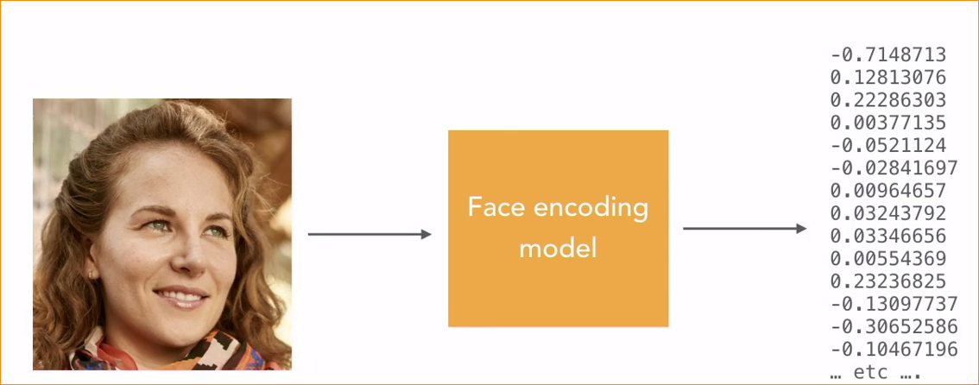

If we feed same person in a different image that numbers closely equal.

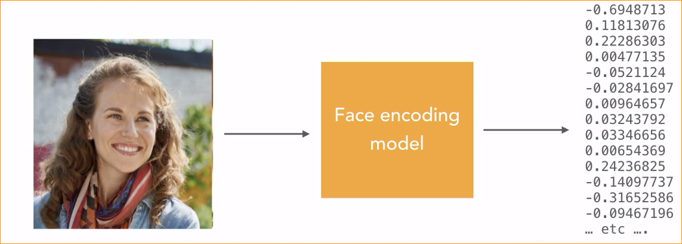

In face recognition we can use pre trained model.

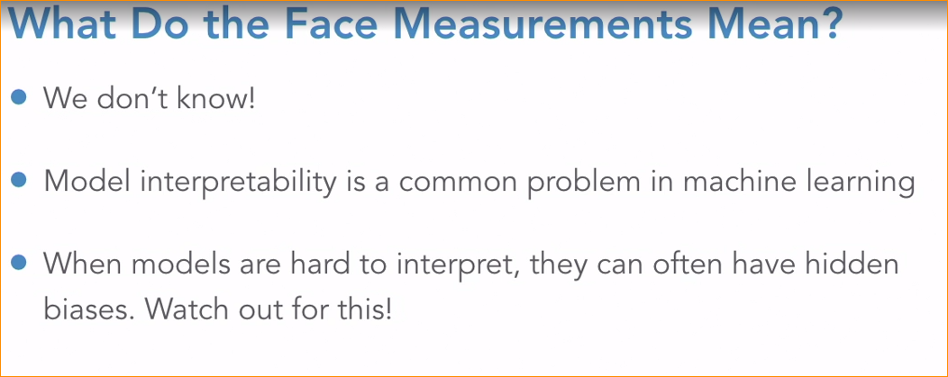

Code –

Import face recognition library -



Load image into memory-



Generating face –encodings is a multi-step process that involves locating a face in the images. Finding all the facial features for that face, aligning the image, and then processing the image with pre trained face encoding neural network.this library doing everting. Result of the function is array.

Each element in the array represents one face that was found in the image. 128 elements that represent a unique face.

Feed the model –



Here I check the size of the array, that mean no face were detected image length goes to zero.

